English Test for Second Grade

Name: ________________________________
Date: _________

L Cárdenas 509, Santa Cruz Buenavista Norte, Sta Cruz Buenavista, 72150 Puebla, Pue.

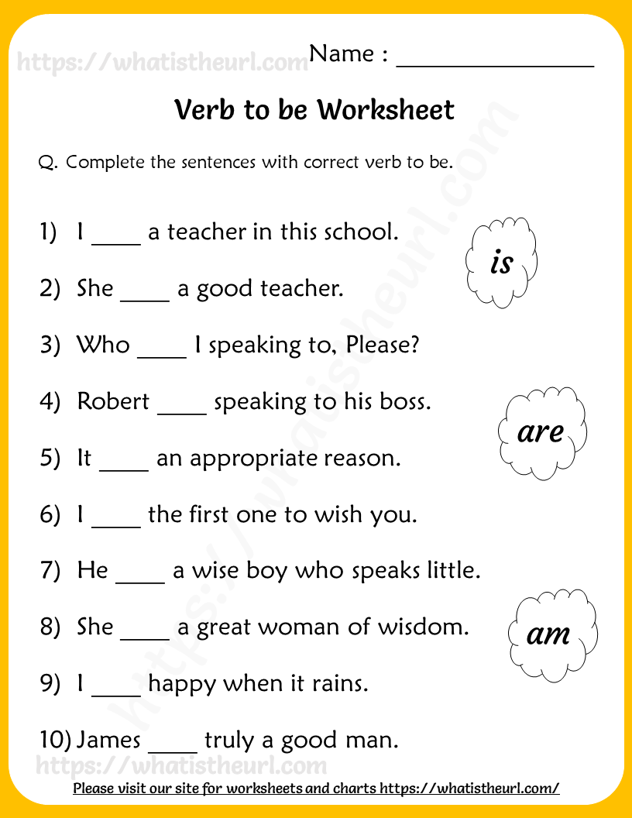

Read and answer.

